MASCHERPA Audric ROB 3 2022 / 2023

**POLY-SNAKE**

**Weekly report n°22 from 02/05/23 :**

In anticipation of the oral passage that will conclude our PolySnake project next week, we have focused on fine-tuning the details.

First, I started the week by adding capacitors to avoid voltage drops. My calculations having not borne fruit, I decided to use 1000µF capacitors which after a few tests seem to work very well on our project as shown in Figure 22.1.

Figure 22.1

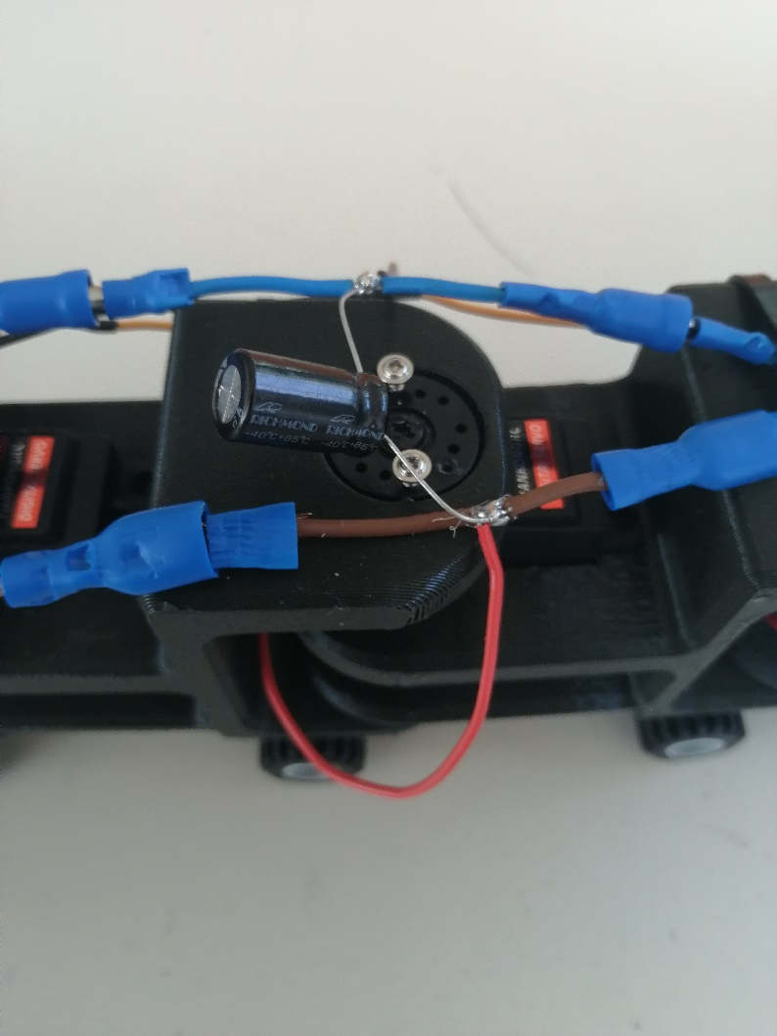

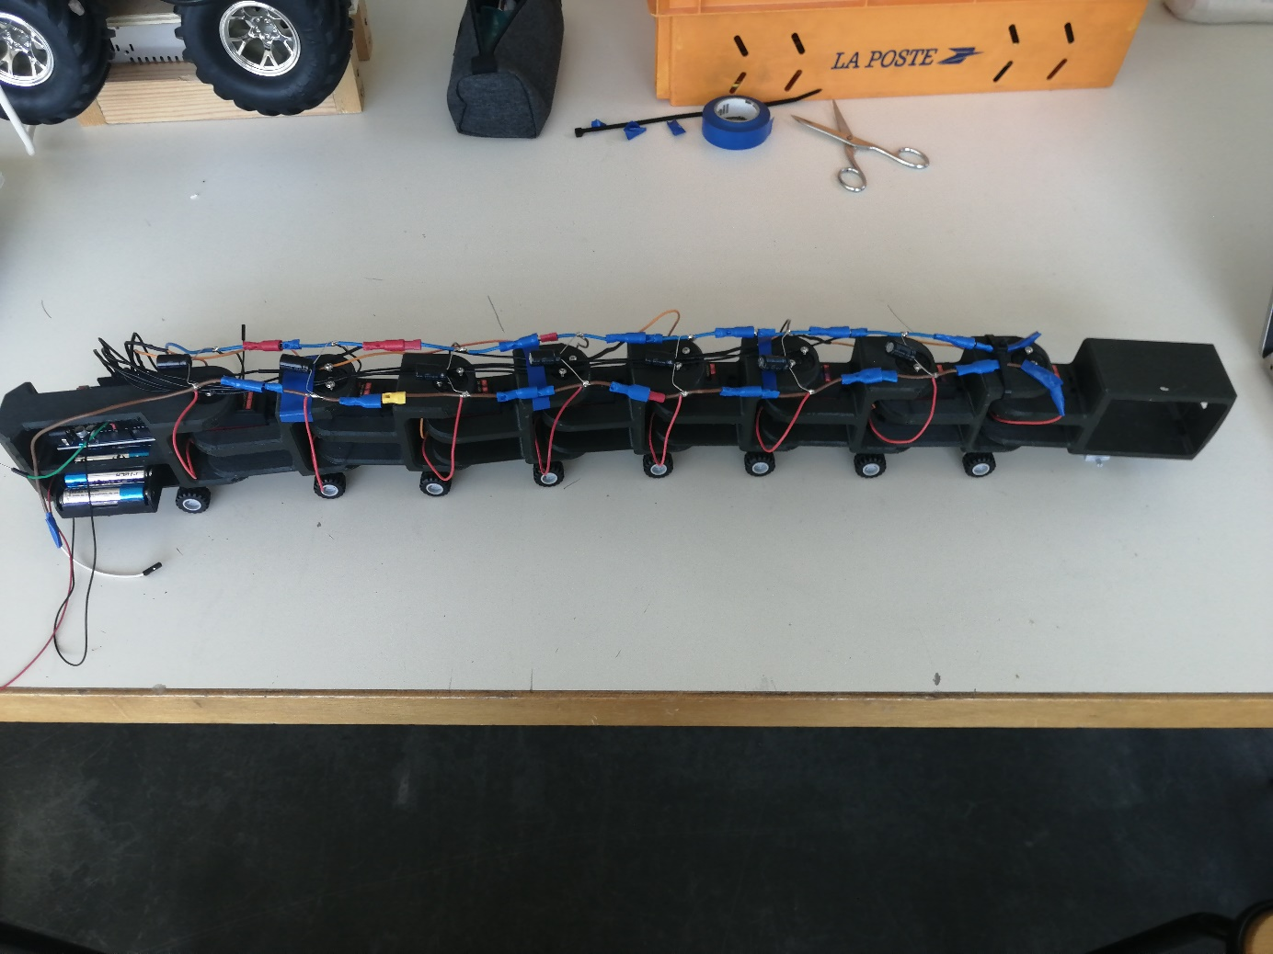After performing this step on all the servomotors, you can see the result in figure 22.2.

Figure 22.2

Once this step was completed and after restarting several welds which was the cause of bad contact and therefore poor power supply to the snake, I finally managed to power our project in 6.5V using 5 batteries varying between 1.2 and 1.5V and which allow to have a good movement of the snake using the Younousse program.

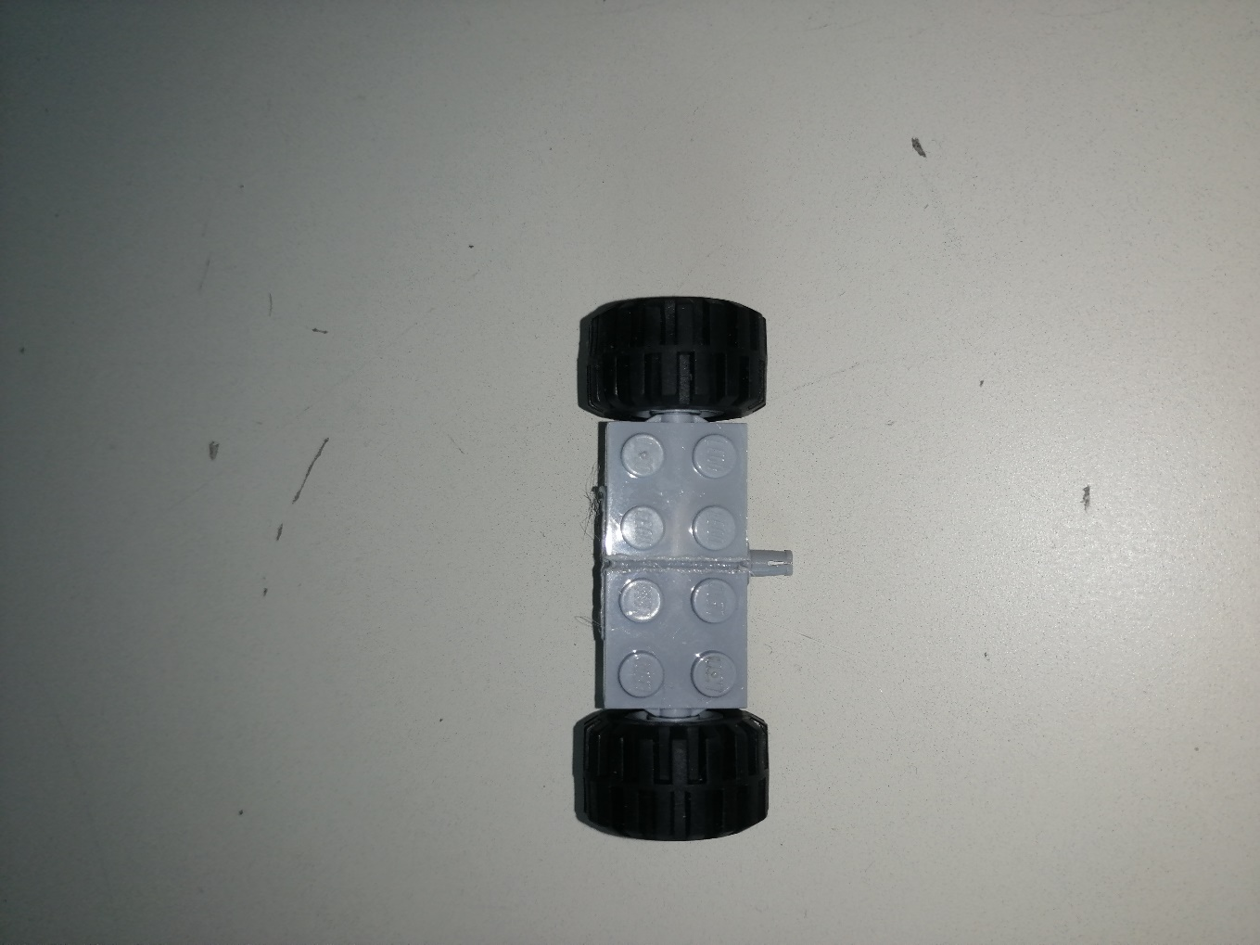In addition, in order to be able to separate the Lego wheels, I decided to weld them together so as not to have any unpleasant surprises during the presentation of the project as in figure 22.3.1 and 22.3.2.

Figure 22.3.2

Figure 22.3.1